Oracle Cloud Infrastructure Data Integration
As a refresher, OCI Data Integration is a cloud native, fully managed server-less extract, transform, and load (ETL) service on OCI. Organizations building lakehouses for analytics and data science, artificial intelligence and machine learning on OCI with Object Storage, and Autonomous Data warehouses can quickly deliver insights by simplifying, automating, and accelerating the consolidation of data from multiple data silos.

Data Integration provides a graphical, no-code design interface, with interactive data preparation and profiling. It also helps data engineers to design data pipelines using patterns and rules to handle schema evolution. It supports both Spark ETL and ELT push-down processing to the database. If you’re not familiar with this new service, check out the blog, What is Oracle Cloud Infrastructure Data Integration?

How to Upload JSON file in ATP database using Oracle Cloud Infrastructure Data Integration
Flattening operator in Data Flow:-
With this new srelease, OCI Data Integration now supports the flattening operator in the data flow, where users can flatten the hierarchical structure like arrays in JSON into a relational format. When the complex data is flattened, you can perform transformations, aggregations, joins, and load into the target.

Key Feature: Flattening Operator in Data Flow
- Description: The flattening operator allows users to flatten hierarchical structures like arrays in JSON into a relational format.
- Process:
  - Select FLATTEN link with Source: Choose the flattening option for the source data.
  - FLATTEN Operator Detail: Configure the flattening operation by selecting the appropriate hierarchical key column.
  - Flatten Data Selection: Click on the "Flatten data to select attribute" button to map and transform the data.
  - Hierarchy Column Population: Populate the hierarchy column with an alias.
  - Data Check: Verify the data in the JSON file using the flatten data property.
  - Add Target Table: Add and map the target table columns for the transformed data.
  - Data Flow Creation: Complete the data flow process and ensure all mappings are correctly established.

Navigation menu – FLATTEN operator in Navigation Menu
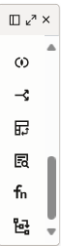

Select and drag FLATTEN operator and link with Source- In Navigation Menu drag FLATTEN operator and link with source.
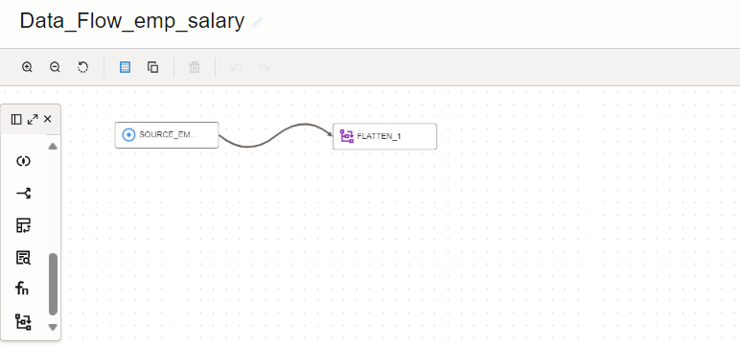

FLATTEN operator Detail-In FLATTEN operator you can check four options. click on details tab and check.
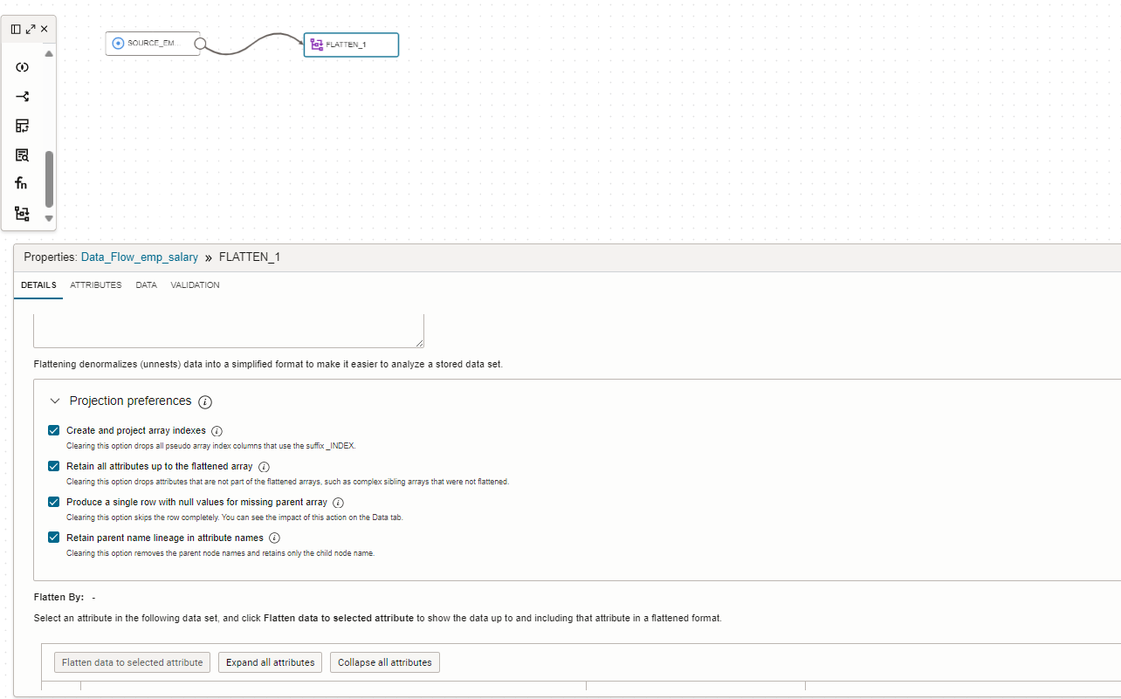

Select respective Hierarchy Key column.
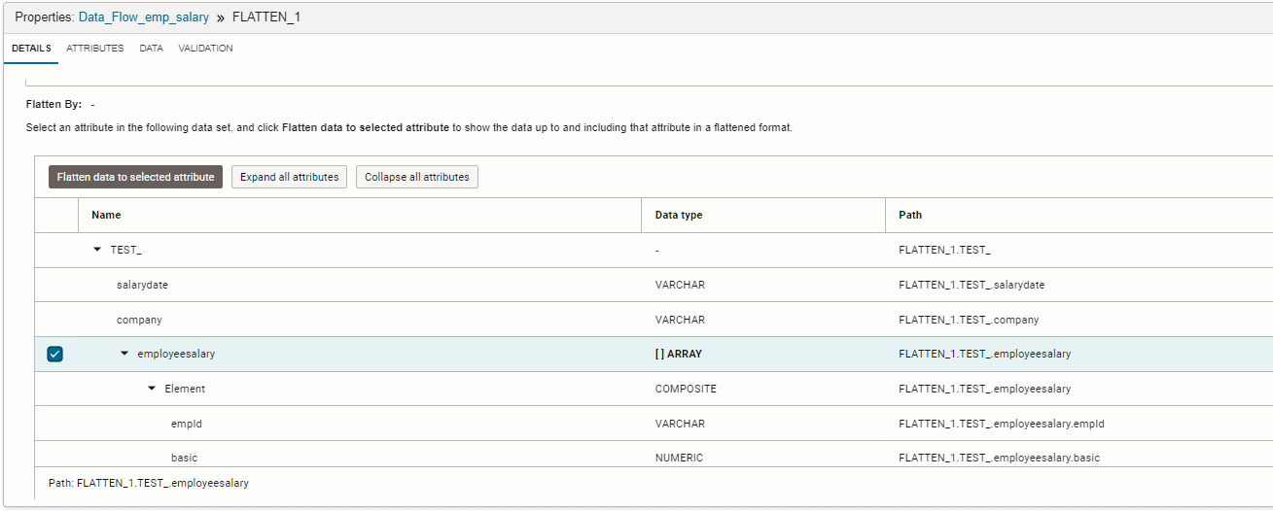

Click on Flatten data to select attribute button
Click on Flatten data to select attribute button
Hierarchy column populate with alias-
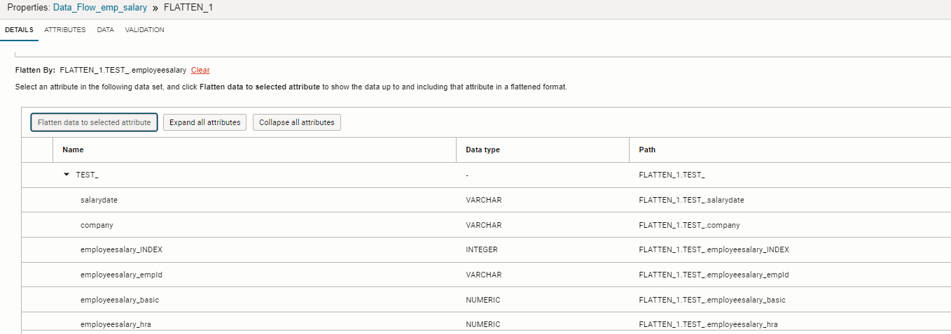
Check data in JSON file using Flatten data property
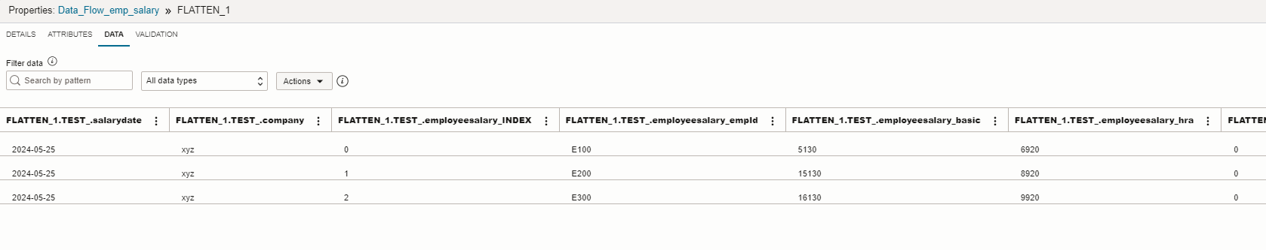

Add Target operator inside Target table
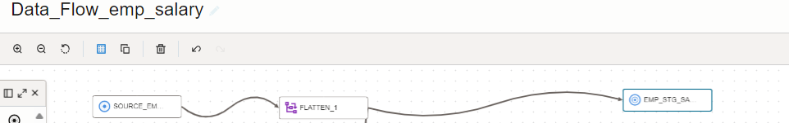

Target table column:-
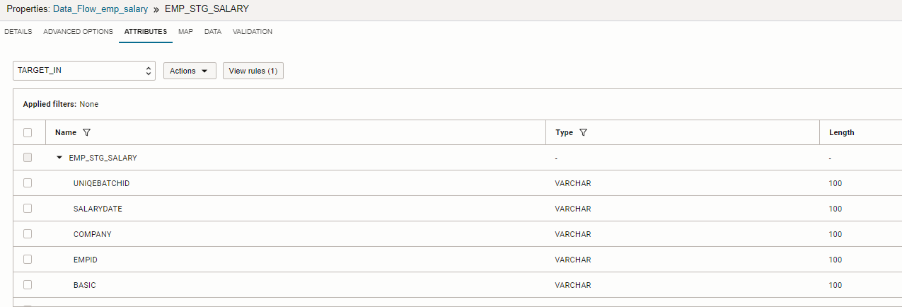

Data Flow
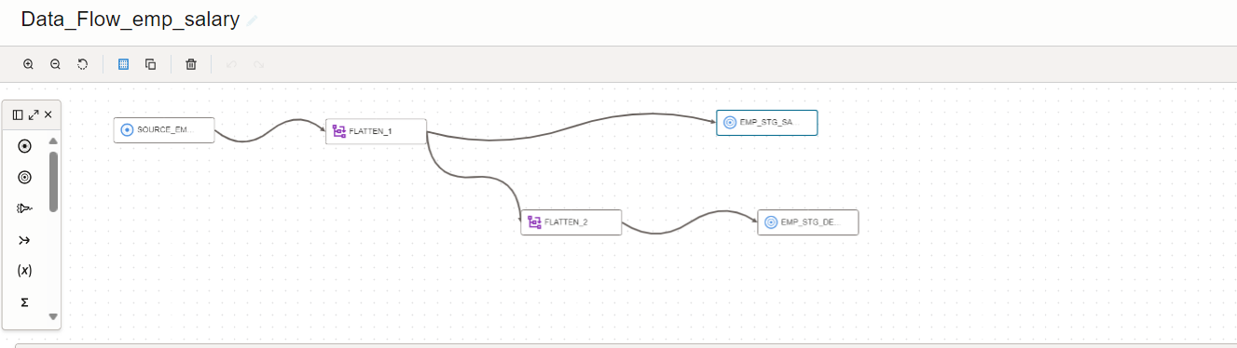

Target table Mapping
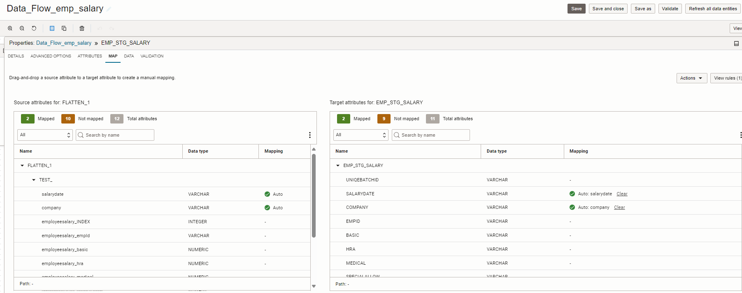

Mapped field-
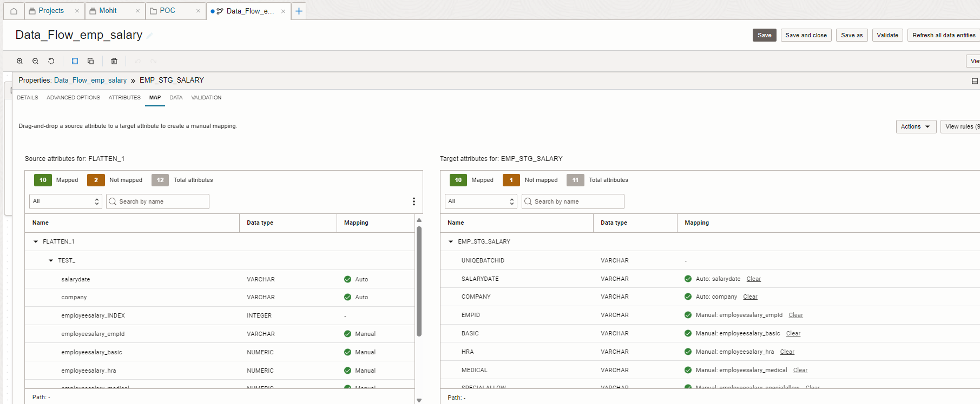
Data flow created
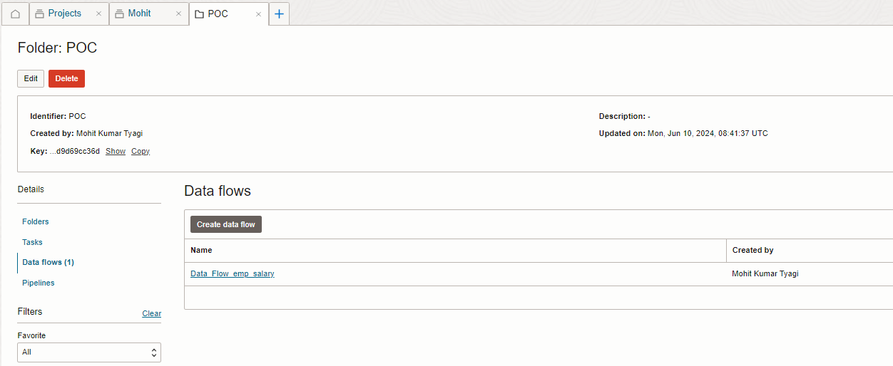

Create Data integration for this data flow and publish your integration and run you will get your source data in your staging table.

